Alexandra Gross

Megiel Kerkhoven

Casper Van Der Vliet

**Dutch Parliament Voting Trends**

**Introduction**

Around the world, political polarization is becoming more and more prevalent, referring to “cases in which an individual’s stance on a given issue, policy, or person is more likely to be strictly defined by their identification with a particular political party.”[1] Polarization can also include the strict adherence to party lines, and an increase in divisiveness overtime. Political scientists often identify between two categories of political polarization: “elite polarization,” which refers to the polarization of elites such as elected officials, and “popular polarization,” which refers to the ideology of the public.[2] As discussed later on, elite polarization and popular polarization can have major effects on one another. Polarization occurs all around the world; but is especially apparent in two party systems where there is little-to-no collaboration between opposing parties. For example, political scientists have characterized the United States as “two one-party”, nations instead of one two-part nation.[3] Issues the country debates about - immigration, culture, the economy, race, gender - divide Americans consistently under party labels. Republicans are typically unified around one set of regulations, while the Democrats are united around another. However, in the Netherlands, the issue is less black and white.

**Recent Research and References**

Given the multi-party system in the Netherlands, there are a multitude of parties that range in ideology and platform including Christian parties, left-wing liberals, populists, and more niche parties such as 50+ and the party for the animals. Overtime, the political parties in the Netherlands have transformed, but for the time range we chose to focus on for this research project- 50 Plus, CDA, CU, D66, Denk, GL, PvdA, PvdD, PVV, SGP, SP, and the VVD were all in power. There has been similar research conducted at the University of Amsterdam that used cross-perspective modeling as a way to “extract political party’s positions from parliamentary proceedings.”[4] Using data from 1999, 2002, 2006, and 2010, researchers used opinions to rank the parties on a sliding left and right scale. However, they were unable to make sound conclusions regarding whether “differences between opinions correlate with other politically meaningful dimensions.”[5] For our research project, we were interested in using a more recent time frame to study whether a certain network of these parties tended to vote together in the Dutch parliament.

**Operationalization of the Research Question**

Studying the voting trends between political parties in the Dutch parliament would unveil whether parties share similar political philosophies vote together on particular topics. Additionally, this question highlights if the behavior of parties in the public corresponds with their voting behavior and demonstrates whether parties who have governed together tended to vote similarly. Recent research has highlighted that after the rise of Geert Wilders and Pim Fortuyn, the amount of polarization across Dutch society has increased more than it otherwise would have.[6] This finding unveils the relationship between the elite and mass-polarization, as well as the consequences of the emergence of populist radical parties in Western Europe.[7] There is an reciprocal effect in that radical parties are found to succeed under conditions of mass polarization, while additionally contributing to the polarization of the public.[8] To better understand this cycle and polarization in the Netherlands, we chose to focus on the parties voting behavior to see if there are clear patterns and trends in the Dutch parliament.

To answer this question, we chose to focus on a three-year time span between 2013-2016, and using all votes conducted by the parliament during that time period. The three-year time span allows our conclusions to be grounded on trends from 10.255 votes. Additionally, while our research covered all voting matters, it would be interesting to see how the trends varied on different matters such as immigration, the economy, and social issues. Before answering our overarching research question, we needed to break it down and compare each pair of political parties to see how often they voted the same. Once all parties had been compared using a correlation analysis with SPSS, they could be visualized using network analysis with the software Gephi to highlight trends between groups of parties using thresholds on the percent of agreement and conclusions could be drawn. Any revealed grouping of political parties can help with predicting voting behavior in the future, and to better understand the polarized nature of Dutch politics today.

**Provenance, Promises and Limitations**

The provenance of the data is votes that are held in the parliament of the Netherlands in The Hague. Votes could be conducted by hand raising or an individual vote. Records of these votes have been collected and posted on the official website of the parliament of the Netherlands.[9] On this website there is a record of all the votes executed by the parties and members of parliament. These documents are sorted by year and document number and consist of motions, amendments and general votes throughout the year. We used a script which searched the year of publication and the document number, to retrieve all the documents in the period of 2013-2016 and gathered these inputs in a data set. These steps will be further explained in the data curation section.

The promises of the data are that we are able to analyze voting patterns in the parliament and therefore can see which parties do and don’t tend to vote together. Based on these observations we are able to ask questions which can comprehend broader themes. These questions can contain the influence of the current coalition or the political ideology of parties in the voting pattern. It is also possible to shed a light on the level of polarization between the different ideologies. Another promise of the data is that it shows if a vote is either approved or rejected. With this information you can ask questions concerning the rate of votes that gets rejected or approved. This could be useful information for policy makers. You can also research how much of the votes are done by raising hand or an individual vote. This information on how the voting is done, instead of the outcomes could be promising for political scientist.

Although complete, the data set has certain limitations. First, the information is quite “raw”. The data set contains just votes of the members and nothing more. The Dutch parliament is subjected many fierce debates, where political opponents question each other’s opinions before the voting is conducted. These debates could influence the voting but are not represented in the dataset. Therefore, the conclusions that you can make on this topic are limited. Secondly, there is no account of the subject of the votes in the data set. Different political parties tend to vote together on certain subjects, while against each other on others. Political parties like D66 and Christen-Unie could vote together on economic themes, but against each other on ethical debates. Likewise, voting on themes like culture and national identity will have completely different outcomes then votes on social security and welfare. Therefore, findings answers on questions that go deeper than voting patterns are challenging.

**External Resources**

We have used a number of external resources. One of these resources is the website of the Dutch parliament. The Dutch parliament is very transparent on its website on the votes during the parliamentary meetings. The website is analyzed with a script that was provided by.[10] This page explains that getting the data from the parliament is a high effort job. The owner of the website is Stephan Okuijsen and he decided to write a script that subtracts the data from the website of the Dutch parliament. The script subtracted the data between 2013-2016 and the output that was provided was put into a dataset. When curating and analyzing the data we made use of SPSS. This is a program used for statistical analysis. The benefit of SPSS is that you can curate and analyze your data via syntax. This way the original file, the curated file and all the steps that we took in SPSS are really transparent. If you save your changes in SPSS syntax, other researchers can trace every step you took in your data preparation phase. The steps taken in SPSS will be further explained in the data curation part. We also made use of a visualizing program named Gephi which made it possible to make a network analysis and visualize it accordingly. Gephi operates by combining a nodes file which contained all the political parties, and an edges file which included the weighted edges between each pair of parties.

**Steps taken to curate, enrich and query the data**

The dataset that we use is a dataset containing three years (2013-2016) of voting behavior on motions of members of the Dutch Parliament (Tweede Kamer). The dataset is really complete and does not have missing values in any of the variables because of how it is created.

The dataset is created by a python script that automatically generates the data. The script tries every possibility for a web-URL on the site of<https://www.tweedekamer.nl/kamerstukken/stemmingsuitslagen/detail?id=yyyyPxxxxx>. In this URL, yyyy is the year and xxxxx is the following number (like an id-number). The script runs every possibility of xxxxx for yyyy=2013, yyyy=2014 yyyy=2015 and yyyy=2016. It thus ‘visits’ the sites that contain all the published vote reports by the Tweede Kamer website. The script is then set to track information from these websites and write them into a data case. The script then registers how parties voted and for how many members of the vote this is true. Most of the times a party will vote unanimously but sometimes some party members will vote differently. The system then automatically writes down how many members voted ‘yes’ and how many ‘no’. Every party’s vote is put into a single case in the dataset. The system also tracks document numbers, date, dossier numbers, the type of vote (by raising hand or by summoning of each member), type of document (law, motion or amendment) and the final result of the vote. The script did this for 10.255 votes in total, resulting in 143.349 cases because each party’s vote becomes a single case. In this parliamentary period, there were 11 parties elected in 2013 and 20 parties in the whole dataset (due to separatists).

The first step was then to make the dataset accessible for non-Dutch people. The dataset was first of all written in Dutch and secondly also had a lot of nominal values which might not mean anything for non-Dutch citizens. Thus, all variables were translated to English and a legend was added to some variables so that when somebody clicks on it (in SPSS) a text shows up that tells you what this variable entails.

The second step was to restructure the data. Ultimately, we want to see how parties vote alike and this is only possible in SPSS if the parties are variables on each vote. This is called making the dataset horizontal instead of vertical. We did this by first making individual variables for each party and then merging all the cases for one vote (In SPSS: ‘casestovars’).

However, this would still mean that there are two variables per party (pro and against) containing the absolute value of how many persons in that party voted accordingly. This would mean that big parties would never show similarities with small parties because the number of voters would differ too much. To solve this issue, we needed a total variable that takes the number of votes out of the equation. This would mean that the variable is binary, either ‘pro’ or ‘against’. However, sometimes individual members of a party decide to vote divergent from their party line. These cases cannot be fitted into just these two categories. This can be solved however by making a third category for these cases. The created variable for each party thus had the values 1 “party voted pro,” 2 “party voted both pro and against (divergent party members)” and 3 “party voted against”.

The choice that had to be made was what to do with the smaller divergent parliament members. In our time frame no less than 9 times (a) member(s) of a party left that party and went on as an independent fraction (two times even 2 members at once). Most of these members were not re-elected in 2017. Some of these parties did not even vote on a quarter of the votes in our dataset. To make the analysis less complex, we decide to leave out the parties that were not re-elected in 2017 (thus including all initially elected parties plus the divergent two-member party ‘Denk’).

Now that each party is represented by 1 variable, a correlation analysis can be done with Pearson’s correlation coefficient. Correlation analysis checks how many times two variables show the same value or a value that is alike (so a 3 and a 1 would correlate less than a 3 and a 2). The Pearson’s correlation coefficient ranges from -1 to 1, in which -1 means zero percent similarity and a 1 means a hundred percent similarity. The correlation matrix that SPSS calculates is shown in the table below:

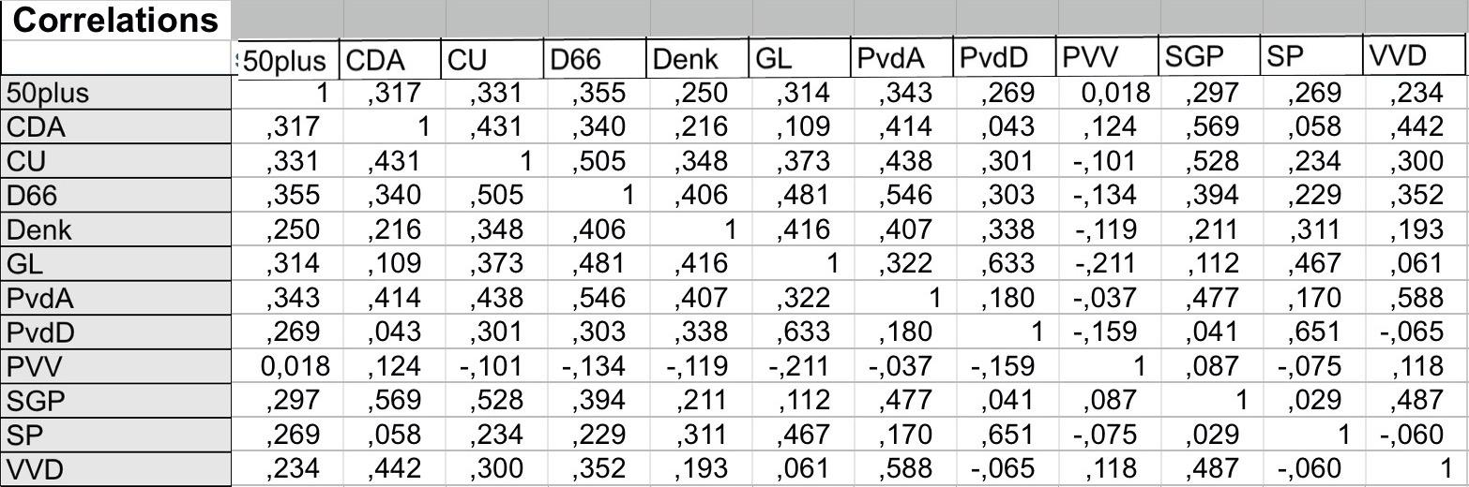

A percentage table can be calculated from the correlation table by adding 1 to each value and then multiplying it by 50 (-1 would become zero percent, zero would become 50 percent and 1 would become a hundred percent). This can be done in excel and the table that it produces is shown below.

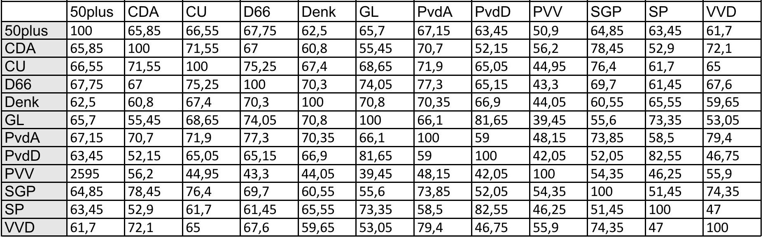

This table shows the similarity in voting behavior in percentages. For instance, the PvdA and the PVV vote the same on 48,15 percent of the votes. From this table we can make a network of parties that vote alike. The average similarity between parties (thus without the 100 percent matches between the same parties) is 62.74%. We wanted to show similarity between parties that vote alike. Therefore, we decided to first try a threshold of 70%. This means that parties that have a similarity of 70 percent or higher will show a line between them in the network. The network that result from this is shown below:

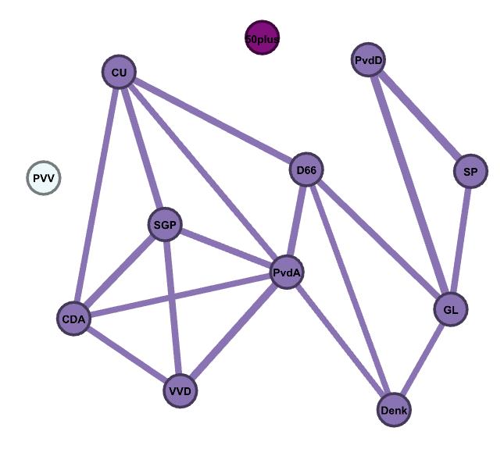**Conclusions**

The results show quite some interesting stuff. First of all, the party with the most edges, is the PvdA. The party is usually seen as a center/leftist party[11] so it is interesting that it voted like the most centrist party in the parliament. Another interesting point is that you can already see a left/right structure that is linked by the parties D66 (center party) and PvdA. Another interesting thing is that the PvdA was in government with the VVD in this time span. During their time of reign, the PvdA got criticized a lot for being too right wing and was said to have abandoned their left-wing voters. In the elections after this critical remark really came through as the PvdA’s share diminished by their biggest loss ever in history, going from 38 (2012) to 9 (2017) seats. The PvdA’s voting behavior thus reflects these criticisms as they vote similar to most of the Christian-democratic (CDA, CU, SGP) or (economically) right-wing parties (D66, PvdA). They did not vote similar to any parties in the traditional left block (GL, SP and to a lesser extent PvdD). It is also interesting how the PVV and 50plus have no edges. PVV is known to be an outsider in Dutch Parliament (as it is seen as extreme-right) and 50plus is a party that has its goal to emancipate people above 50 years old and might thus also vote differently than traditional party lines.

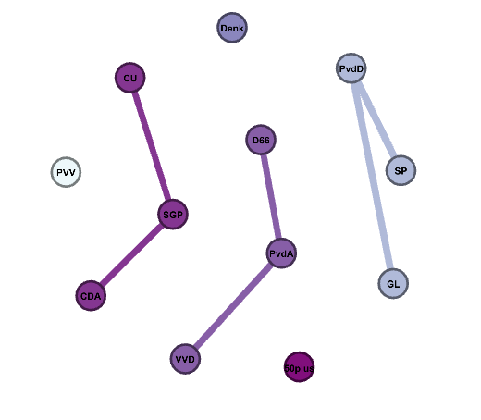

If we increase the threshold to 75 percent similarity (as shown above), the visualization reveals wholly different things. The visualization shows three voting blocks or subnetworks that show similarity in their voting behavior. As Andeweg & Irwin[12] note, Dutch parliament has historically been divided on two dimensions: religion and socio-economic policy. That analysis is mostly supported by our network visualizations. The three-party blocks could be categorized by a religious block (CDA, CU & SGP), an atheist center/right block (VVD, PvdA, D66) and an atheist leftist block (GL, SP and the PvdD). Contradictory to the two-dimension theory is that parliament used to be divided on which form of Christianity a party was connected with. This is no longer the case as all three Christian parties form a single block that is stronger than alignments on other issues.

**Possibilities for future work**

There a number of possibilities for expanding the project. First, we could expand the visualizations to span over a larger period to make the differences between different time periods better visible. We could also expand the data by using the script to the votes of different years and make a larger analysis. It might also be desirable to deepen the research by investigating the votes on different subjects like economy, social welfare, security or privacy. Parties tend to vote differently on these themes and making an analysis of this could be very interesting. We might also want to make a difference between the different voting manners like motions, amendments and law bills. With this information we could research if some parties tend to vote differently in different types of votes. With the data we have, it’s also visible how individual party members have voted throughout the cabinet period. Therefore, it’s possible to analyze how coherent each political party really is, or if there are parties that might have some internal struggles.

1. “Polarization.” *Wikipedia*, Wikimedia Foundation, 28 Aug. 2018, en.wikipedia.org/wiki/Polarization.
2. Ibid.
3. Azari, Julia. “Politics Is More Partisan Now, But It's Not More Divisive.” *FiveThirtyEight*, FiveThirtyEight, 19 Jan. 2018, fivethirtyeight.com/features/politics-is-more-partisan-now-but-its-not-more-divisive/.
4. Zwaan, Janneke M. van der, Maarten Marx and Jaap Kamps. “Validating Cross-Perspective Topic Modeling for Extracting Political Parties' Positions from Parliamentary Proceedings.” *ECAI* (2016).
5. Ibid.
6. Castanho Silva, Bruno. “Populist Radical Right Parties and Mass Polarization in the Netherlands.” *European Political Science Review* 10, no. 2 (2018): 219–44. doi:10.1017/S1755773917000066.
7. Ibid.
8. Ibid.
9. "Recente Kamerstukken | Tweede Kamer der Staten-Generaal". Tweedekamer.nl. https://www.tweedekamer.nl/kamerstukken.
10. Okuijsen, Stephan. "Als de data niet open is | Datagraver". *Datagraver*. https://www.datagraver.com/case/als-de-data-niet-open-is.
11. Andeweg, R. B., and G. A. Irwin. *Governance And Politics Of The Netherlands*. Basingstoke: Palgrave Macmillan Ltd, 2014.
12. Andeweg, R. B., and G. A. Irwin. *Governance And Politics Of The Netherlands*. Basingstoke: Palgrave Macmillan Ltd, 2014.